**Iphone-Ipad Ebook – game app?**

|  |
| --- |
| **This app is very similar to this app. Please review.**  **https://apps.apple.com/tr/app/bible-for-kids/id668692393?ls=1** |

**FEATURES**

* in -app purchase
* Admob support (banner, full screen ad) (This feature should be able to be turned off from within the application.)
* If there is no internet access, stories cannot be read (for ad-supported version)
* Push notification
* Local notification
* Multilanguage support
* Landscape mode only.
* İphone and ipad support.
* Three games. (coloring, match card game, quiz)
* If ads are on, in-app purchase is disabled. All stories are free.
* If ads are off, in-app purchase is active and purchase after parental gate.
* Animations (when tap on)
* All animations, pics, music etc will provide by me.
* Stories will download from my server.

**With ad support turned on:**

* All stories are free
* Banner admob ad on each page.
* Full screen ads before the start every story.

**Pages in the app**

**1. Main page**

1.1. Story List button

1.2. Settings button

1.3. Buttons for stories

1.4. Info panel button

**2. Story List**

2.1 Remove from device button if already downloaded the story

2.2. Download / Buy button

2.3. Close the page button

**3. Settings**

3.1. Narrator voice on/off button

3.2. Music on/off button

3.3. Manage stories button (directs to stroy list (1.1.))

3.4. Languages page button

3.5. About us page button (Directs to 1.4.)

**4. Language**

4.1. The languages those supports.

4.2. Back button

**5. About Us**

5.1. Back button

5.2. Buy all books button

**6. Story cover page**

6.1. Buy only for X button (if ads disabled)

6.2. Buy all books button (if ads disabled)

6.3. Download the book button (if ads are active and/or the user already purchased the book and not on the device)

6.4. Read the story button (If the user already downloaded the story)

6.5. Activity button (If already the user downloaded the book)

6.6. Close button

**7. Story reading pages**

7.1 Back button

7.2. Forward button

7.3. close the text button

7.4. Settings button

7.5. music on-off button (when tap on settings button appairs)

7.6. Narrator’s voice on-off button (when tap on settings button appairs)

**8. The End Question page**

8.1. close button

8.2. Answer button 1

8.3. Answer button 2

**9. Coloring game page**

9.1 back button

9.2 redo button

9.3. undo button

9. 4. paint button with bucket

9.5. paint with brush button

9.6. download button.

**10. Match game page**

10.1. Cards

10.2. back button

**11. Quiz game**

11.1. home button

11.2. Answer button 1

11.3. Answer button 2

11.4. next page button

1. **Main Page**

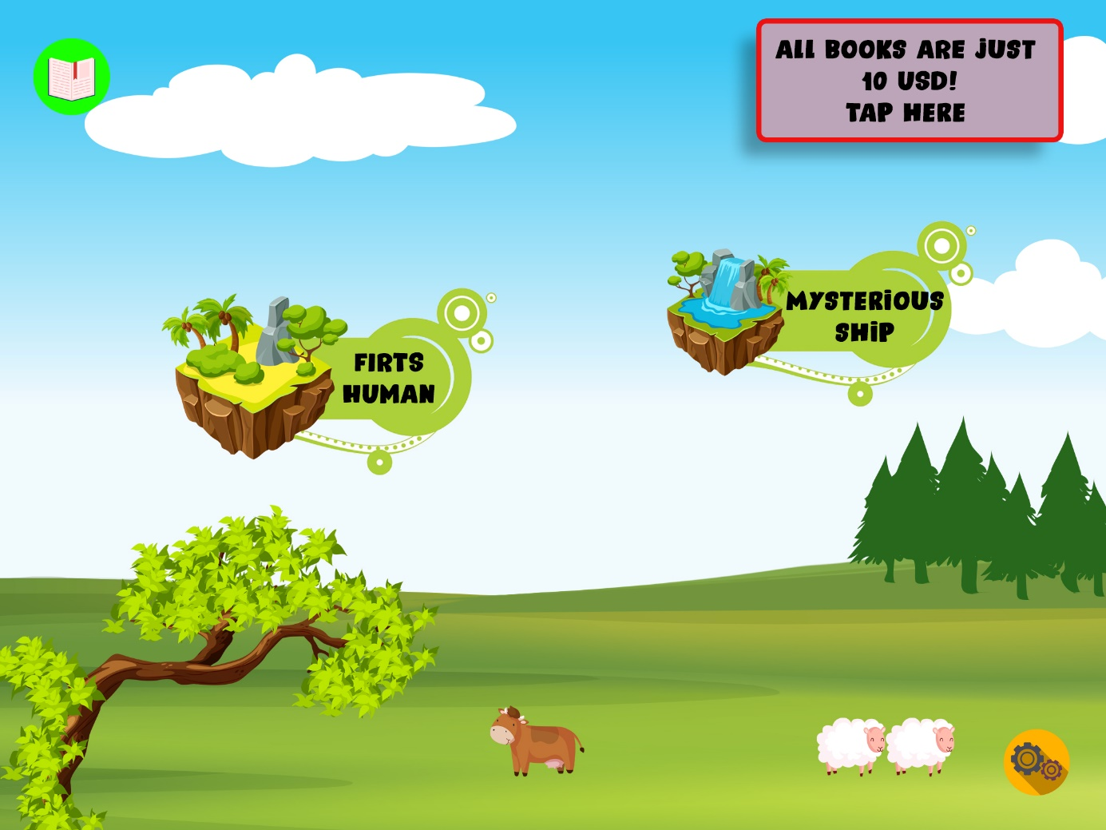

*The application will have general music on the main screen.

* There will be a box on the top right of the main screen. In this box, it will be possible to add and change text from the database. Clicking it will open a page that can be changed from the database. Announcements, discounts, etc. can be found on this page. (About us page)

*The main page is a panoramic picture. It's like a map. There will be animated clouds on the map, animations that move and make a sound when tapped. The map will go on forever as stories are added. There will be story buttons in some parts of the map.

* Main screen can be scrolled right.

* A button on the main page that when clicked will open a list of all books in the application

*Settings button on home page.

1. **Story List**

When tap on :

**IF AD SUPPORT IS ON:**

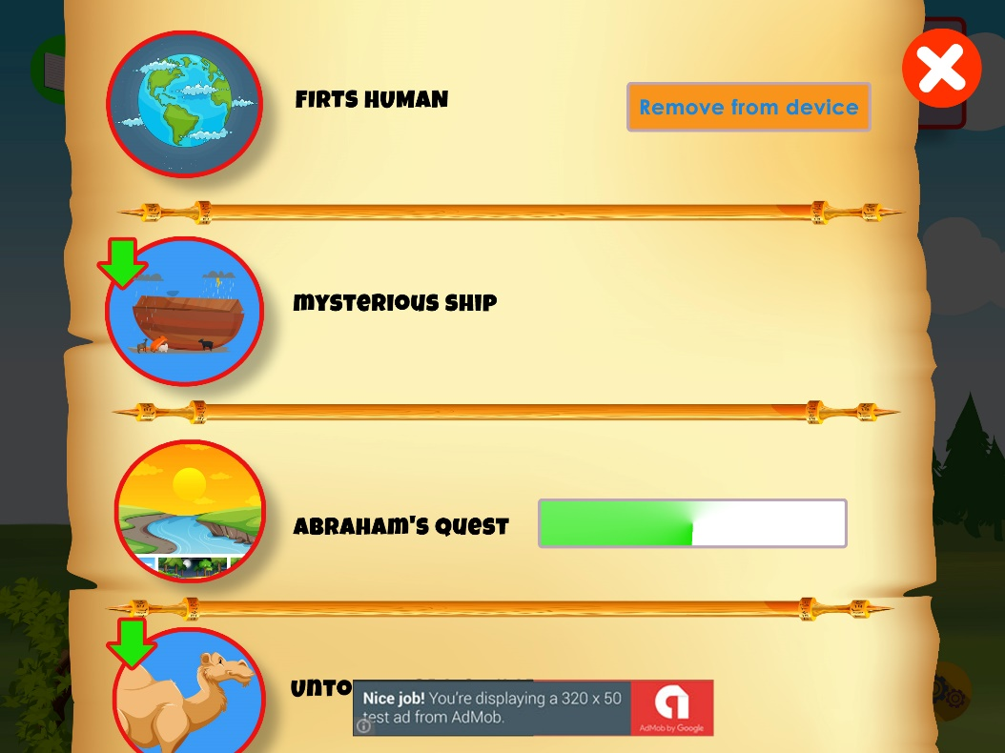

There will be a list of books. To tap the name and it will download. The bar will appear while downloading.

• On the story download page, there will be a green arrow on the icon if it has not been downloaded.

**IF AD SUPPORT IS OFF:**

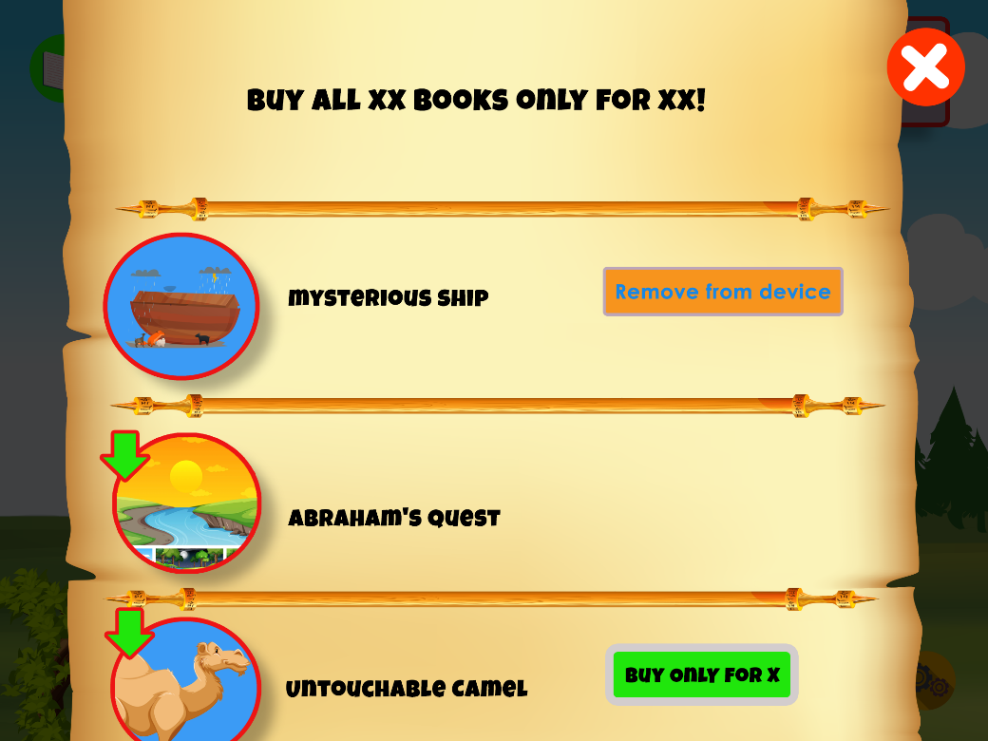

• Only First story is free

• Green arrow on the icon on the story download page if it has not been downloaded.

• Buy all stories section at the top. If it's already purchased it won't show up.

• If purchased but not downloaded (or deleted from the device, there will be a green arrow on the fairy tale icon)

• Purchase will be via parental gate.

**3. Setting**

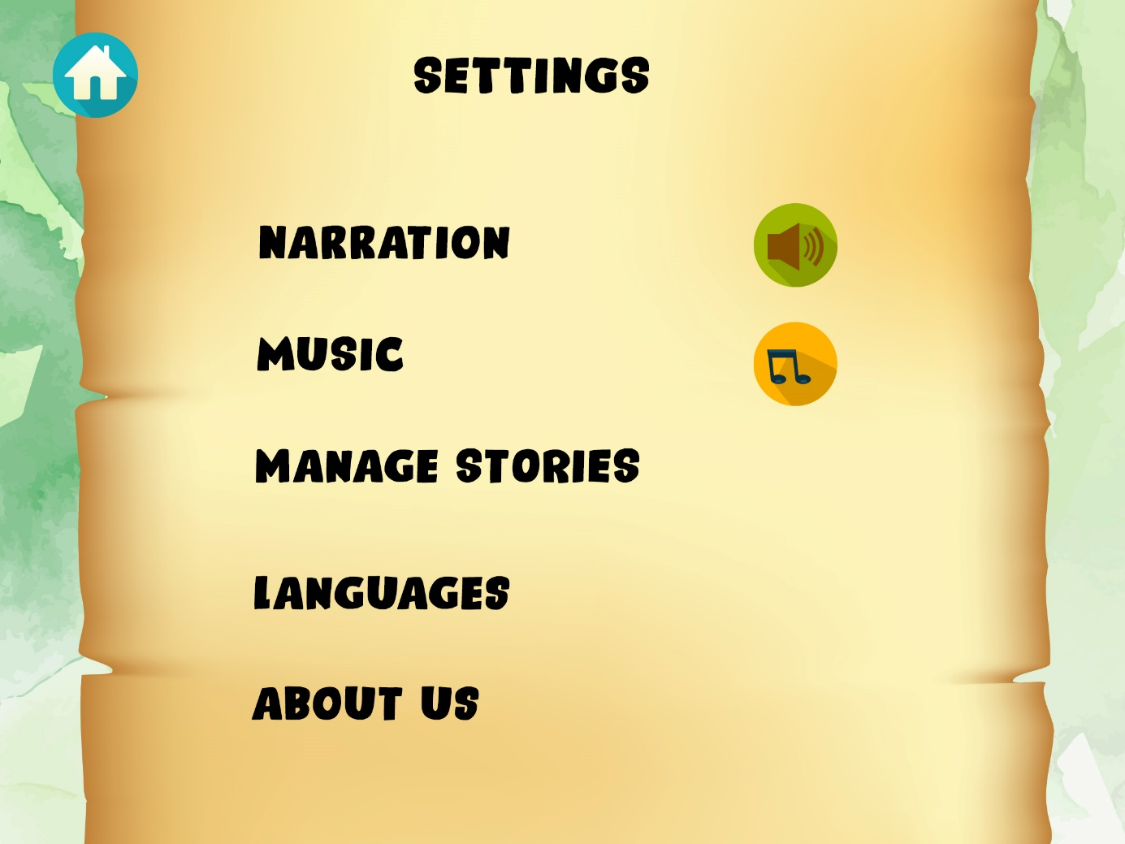

Settings screen on home page

It will open by pressing the settings icon on the main screen.

Narration on off button

Background music on off button

Mange stories button

**4. Languages**

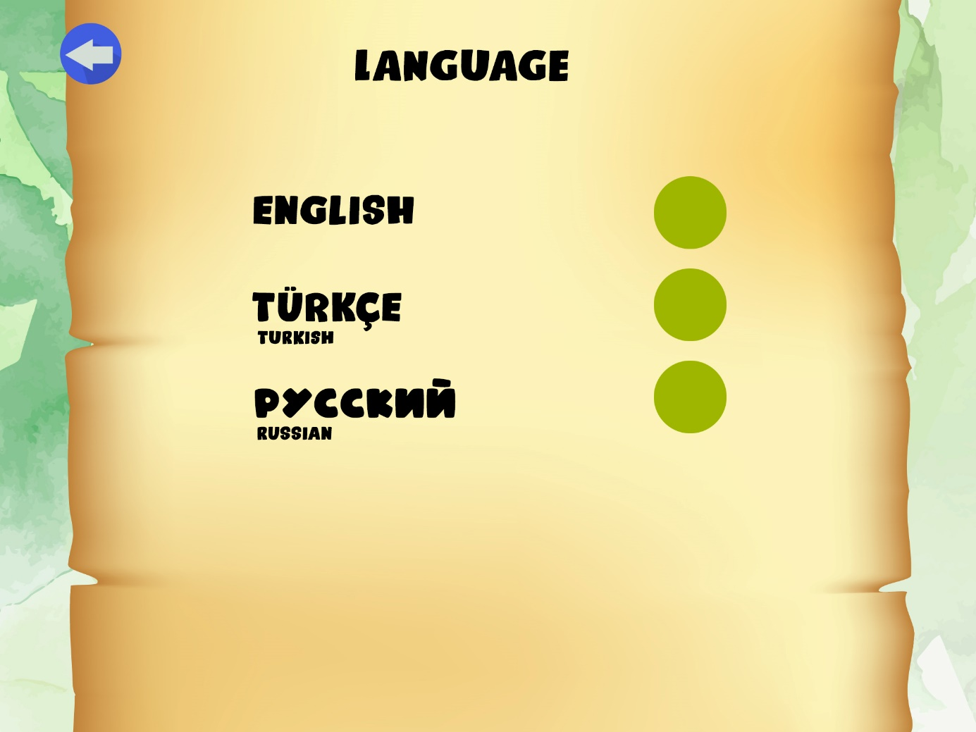

Language button, (The button will not appear if there is only one language.)

About us button

Back button on top left

Language screen can be scrolled down

When on tap the Manage stories button, the list of stories openes. There will be buttons to remove the any story.

There will be a back button at the top left of the page.

Clicking the Languages button will open the languages in the application.

**5. About Us**

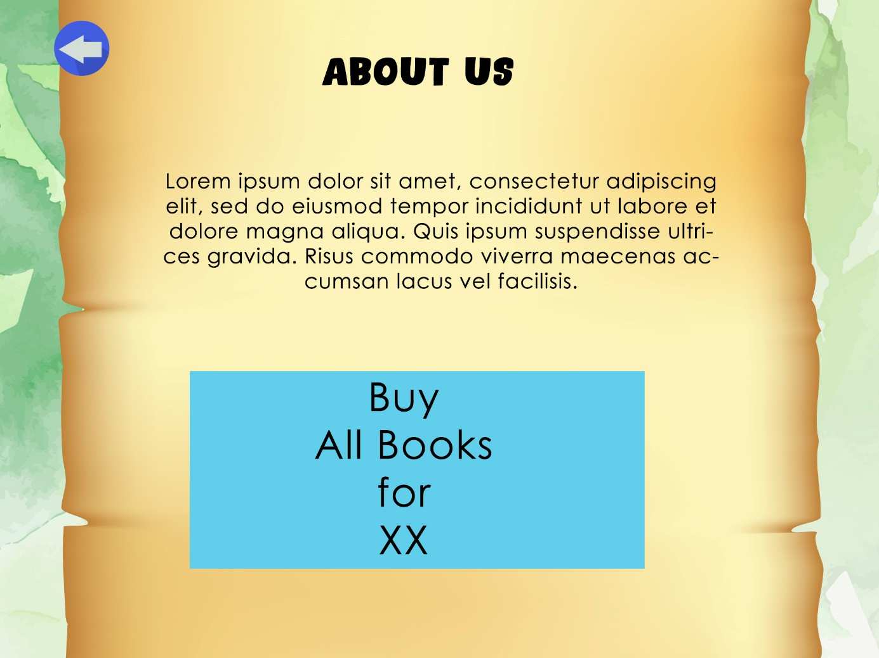

**6. Story cover page**

**IF AD SUPPORT IS ON:**

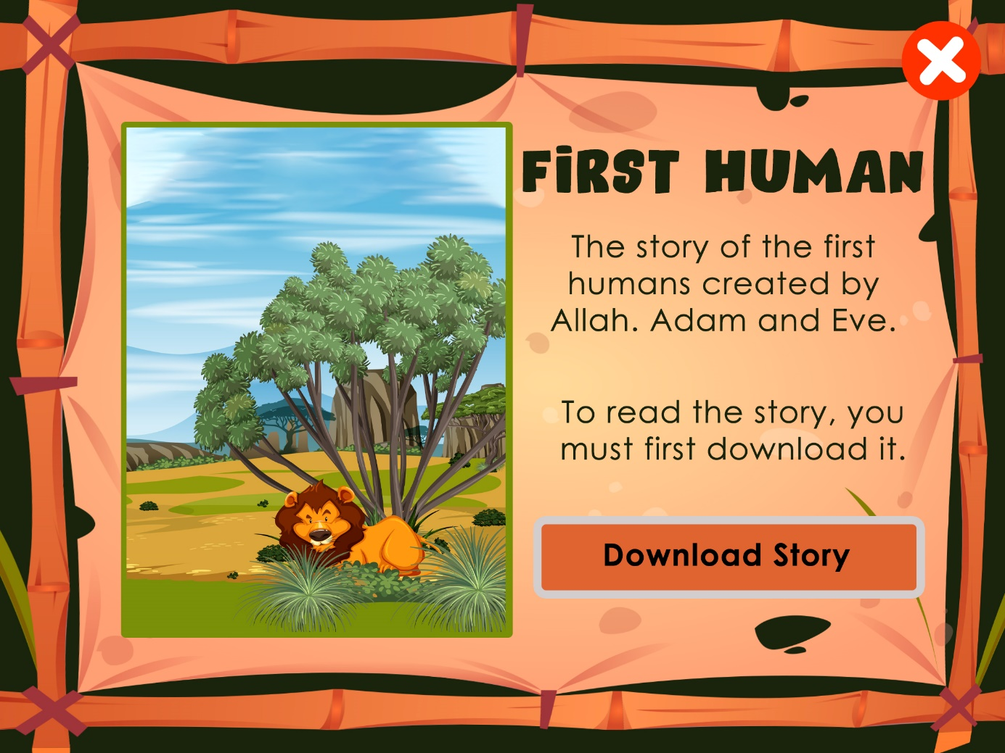

When on click the Story button from the main page, a new screen will open.

The name of the story will be heard from the narator's voice.

Close icon at the top right.

There is the cover of the story on the screen. Next to it will be the name of the story.

There will be a download button. It will write “downloading” while downloading.

When the download is finished, there will be three buttons:

1. read

2. activity (If the story has not been read, the message window "Read the story first" will appear)

**IF AD SUPPORT IS OFF:**

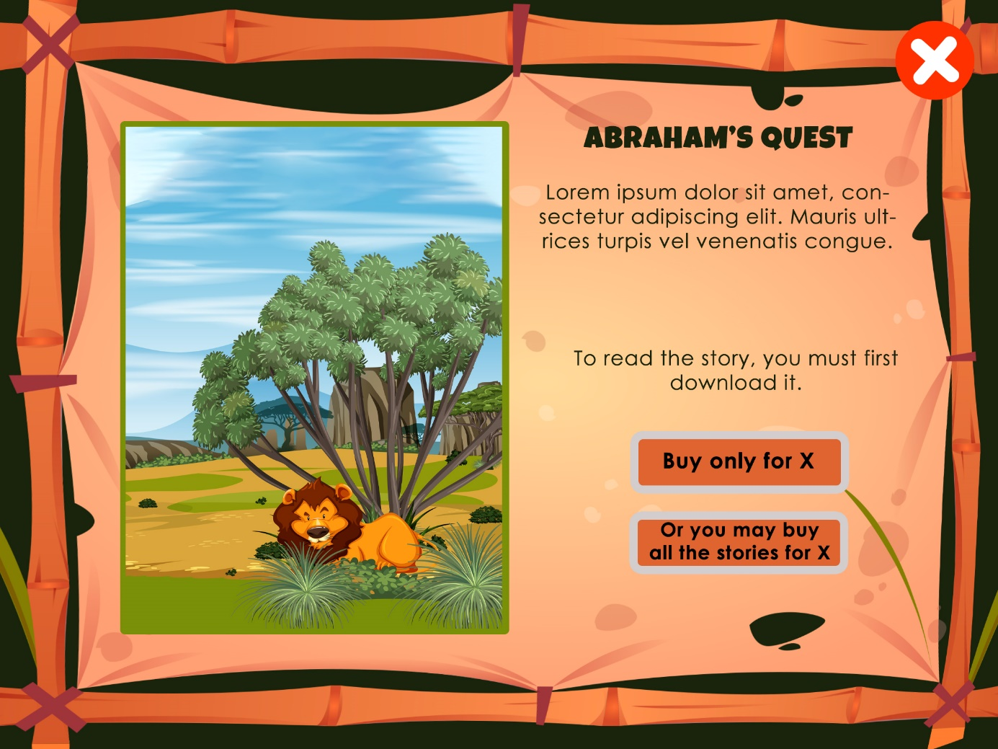

**If ad support is turned off, “buy story only for xx” will be written instead of download story.**

**And under this button there will be anıther button:**

“Or you may get all stories just for xx”

**7. Story reading pages**

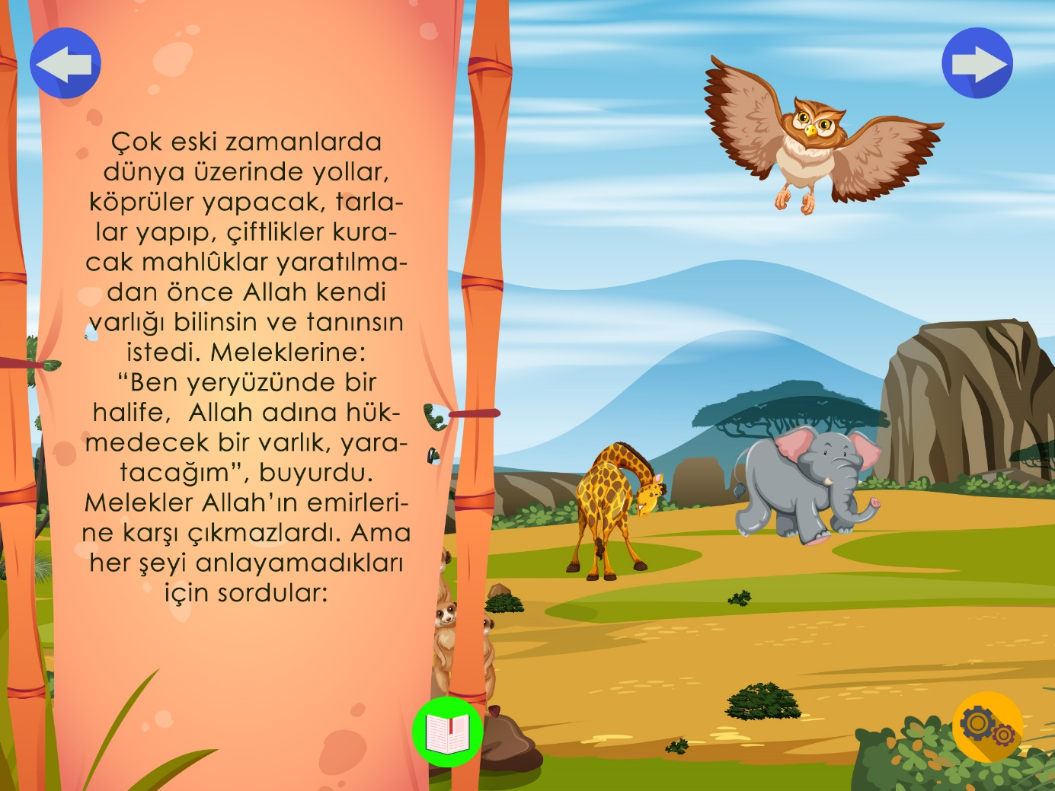

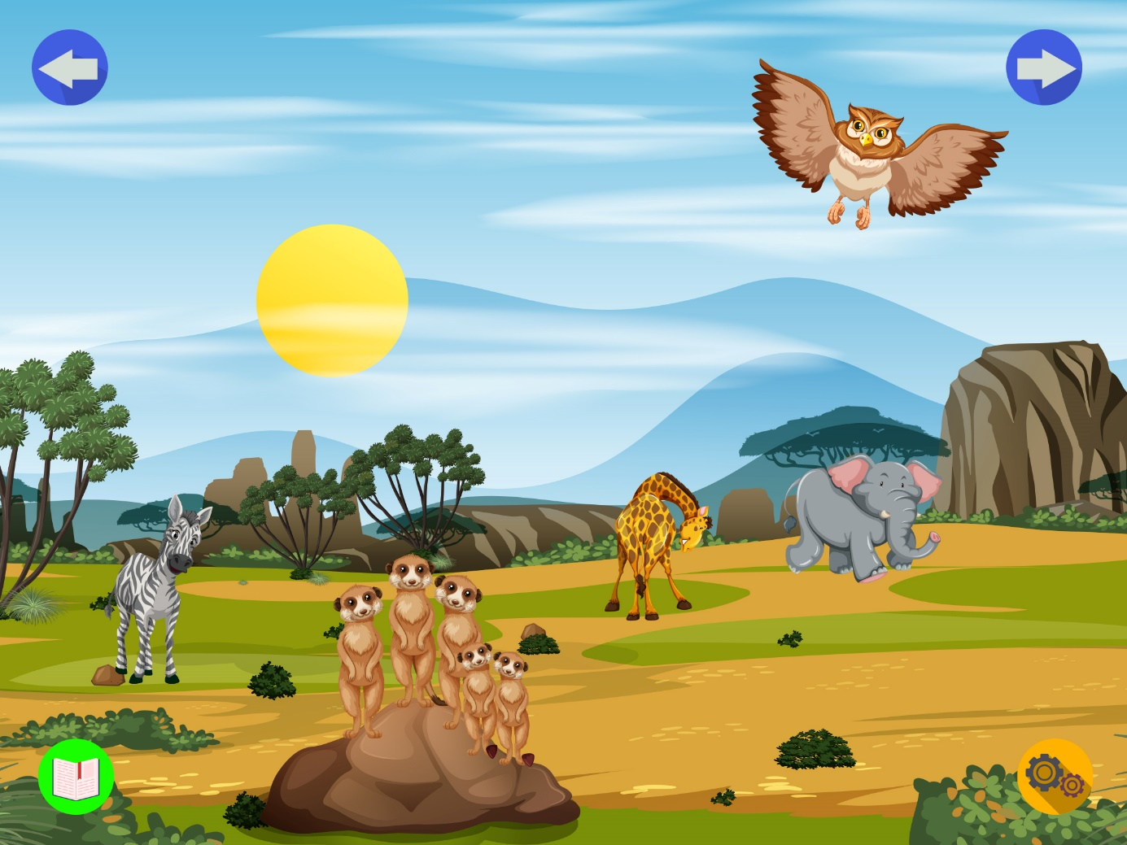

On tap the Read button, the story will open.

A new music will loop play.

The narrator will read the story.

There will be 4 main buttons on the page.

1. Back (upper left)

2. Close text (lower middle)

3. Next page (top right)

4. Settings button (bottom right)

When on tap the settings button, three new buttons will appear animated above it.

1. Return to home page

2. Turn off Narrator sound (on tap the icon will change)

3. Turn off the music (on tap the icon will change)

4. On the story screen, if the used image is large then the screen, the screen will be scrolled.

5. Each story 8 pages + cover

**8. The End Question page**

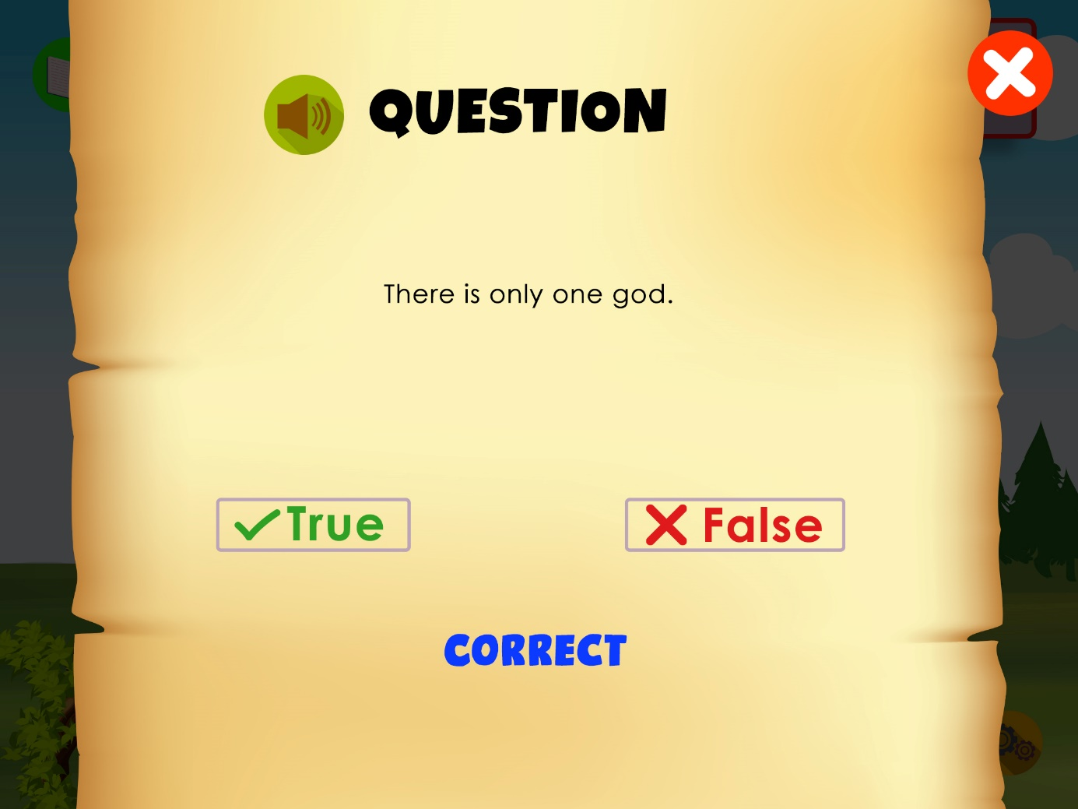

When the story is over, the question screen will open. A question will be asked. There will be yes no buttons.

**9. Coloring game page**

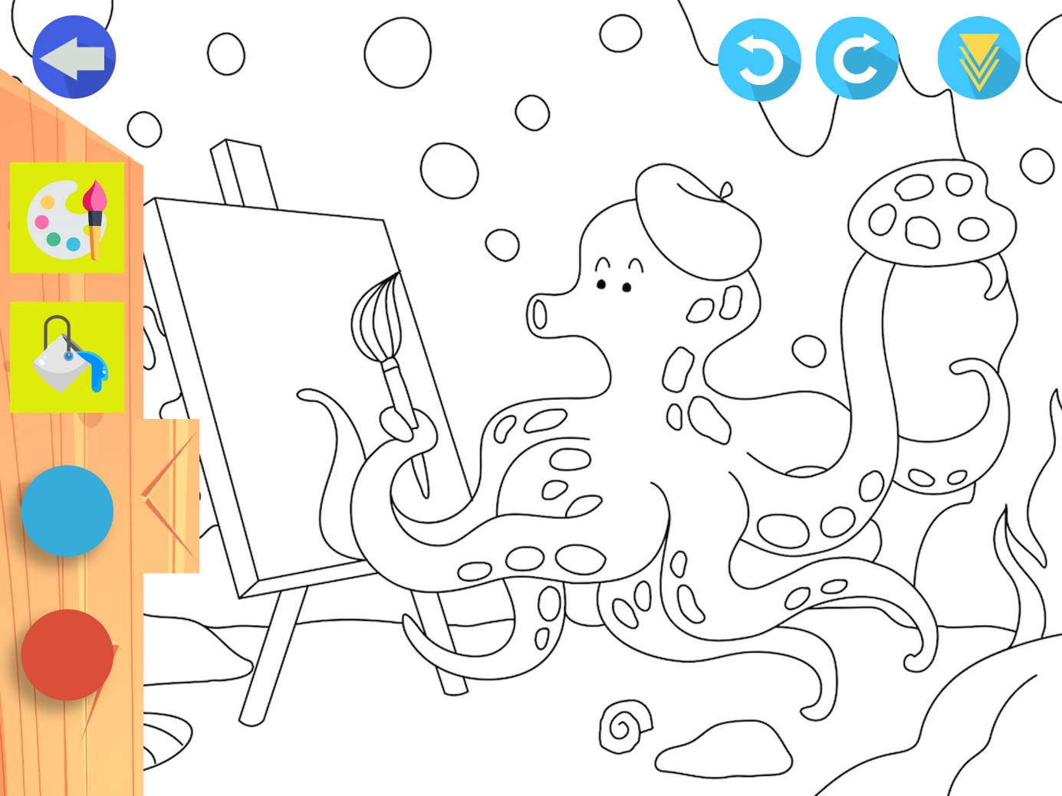

Boyama tool bar can be scrolled down

*movable toolbar.

* Painting options “ bucket or brush”

* colour options

* Undo and redo buttons

* download button. It will just save the screenshot of the picture in the pictures folder.

**10. Card Match game page**

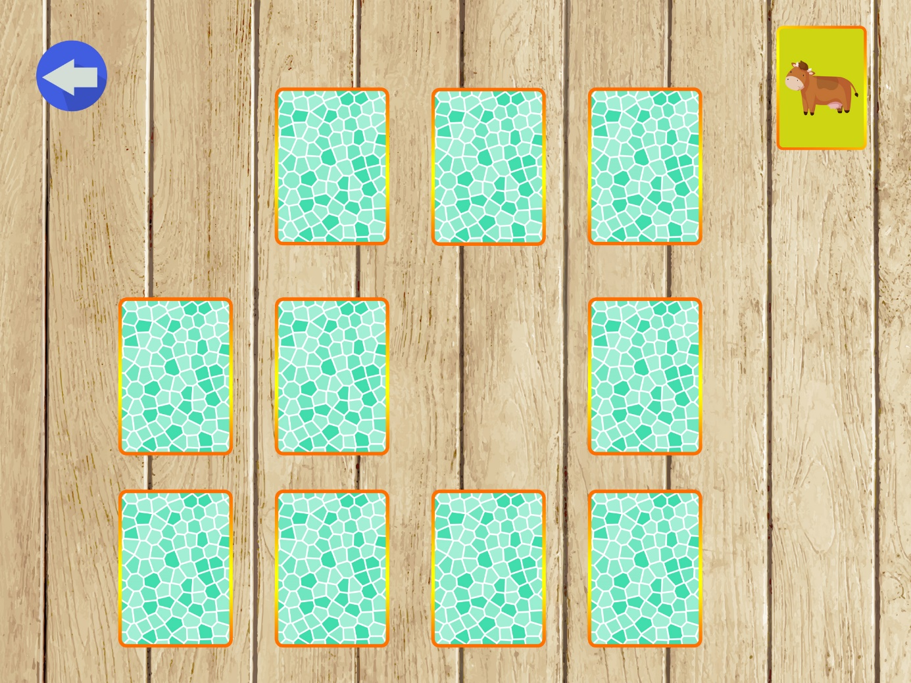 Classic card matching game. Found cards will be sorted on the right

**11. Quiz game page**

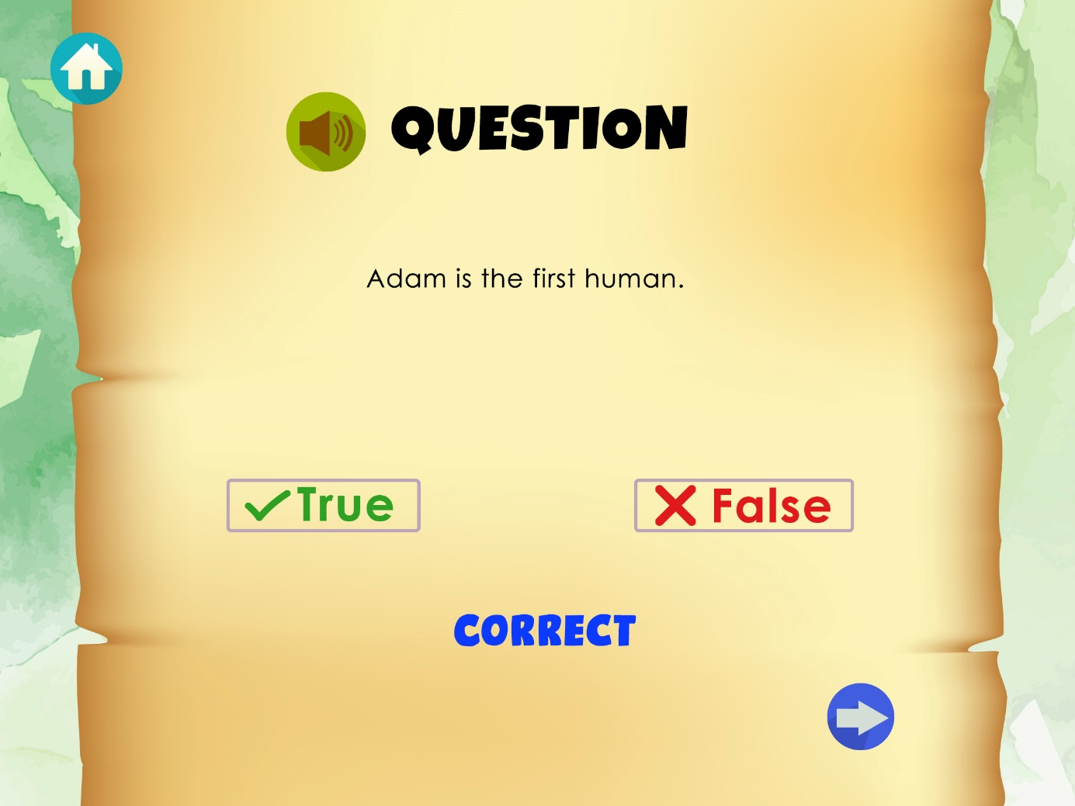

**True false questions game (5 questions):**

There will be false-correct answers. If the correct answer is given, it will be written correct, if it is incorrect, it will be written incorrectly.